Experiment 1

Aim: To write a python code for N-queens problem.

Procedure:

1. **Start with the first row** (row 0).
2. **Try placing a queen in each column** of the current row:
   * Check if it’s safe (no conflicts with previously placed queens).
3. **If safe:**
   * Place the queen.
   * Move to the next row (row i+1).
   * Repeat the process recursively.
4. **If not safe:**
   * Backtrack (remove the queen and try the next column).
5. **If all rows are filled (i == N):**
   * A valid solution is found. Record it.
6. **If no valid placement in a row:**
   * Backtrack to the previous row and try the next column.
7. **Repeat until all solutions are found.**

Code with output:

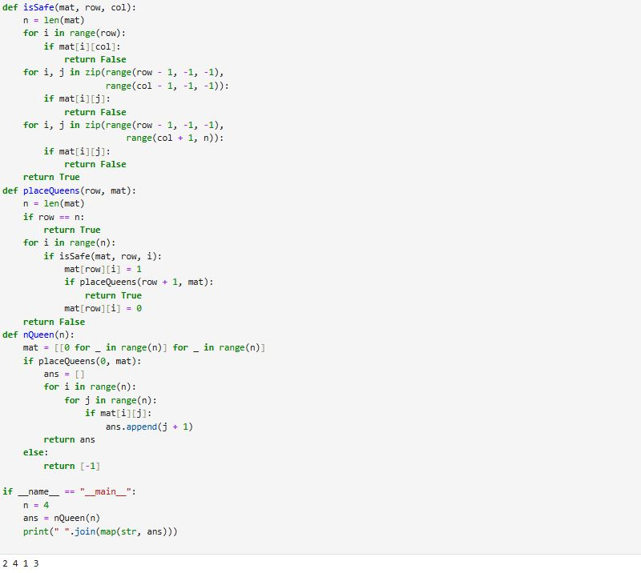

Result:

The code is compiled and verified successfully.